Using the Tool Kit

This Tool Kit is for use in (1) considering changes and revisions to the National MRPC Interpretive Plan, (2) assisting states in developing interpretive plans, and (3) providing guidance for individual attractions and areas along the route that wish to develop their own plans.

The Tool Kit includes three sections:

Interpretive Methods provides users with a wide array of interpretive methods that might be utilized in telling specific stories. It includes advantages and disadvantages, along with special considerations, for each method. Choosing the methods that are right for a given attraction will depend primarily on the story being told and the targeted audience, along with the financial resources that are available.

Visitor Profiles provide insights into the types of visitors that might be traveling the Great River Road. Statistics on each visitor type provide valuable information regarding the needs and interests of various groups. This is by no means an exhaustive list, but it is meant to stimulate thinking about the special needs of different groups that might be traveling the route. Interpretation at each site or attraction should be geared to the groups most likely to visit that particular site or attraction.

Funding Sources provides a bibliography of Internet sites that can direct users to funding sources. In light of the fact that funding agencies are continuously changing, including adding or dropping various grant programs and funding interests, it is important to always check for the most up-to-date information and application guidelines, rather than relying on printed material that may be several years old. The Internet has proven extremely effective in directing users to the most current information.

In developing an Interpretive Plan, first identify the stories that should be told, followed by a determination of the targeted audience or likely visitors to the site. These decisions, tempered by financial resources available, will guide the interpretive methods that are chosen.
3/1

DO NOT COPY THIS PAGE. IT IS HERE SINCE A DIVIDER WILL BE PUT IN ITS PLACE.

Interpretive Methods

Demonstrations

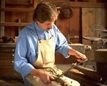
Demonstrations involve showing people how to do something. They are especially good for showing historic ways of doing things, lost arts, or highly specialized areas.

Advantages:

- Give visitors a better understanding of how things work or processes involved
- Can often involve visitors directly by having them participate in the demonstration

Disadvantages:

- Visitor generally must be present at a specific time or on a specific day to see the demonstration
- Must be thorough enough to explain, yet short enough to hold visitors’ interests
- Require presenter with sufficient expertise

Considerations:

- Is attraction or local resource best described by demonstrating the processes or steps involved?
- Is someone available who has an understanding of the processes, as well as ability to relate to audiences?
- How will demonstrations be scheduled for maximum audiences?
3/2
Exhibits

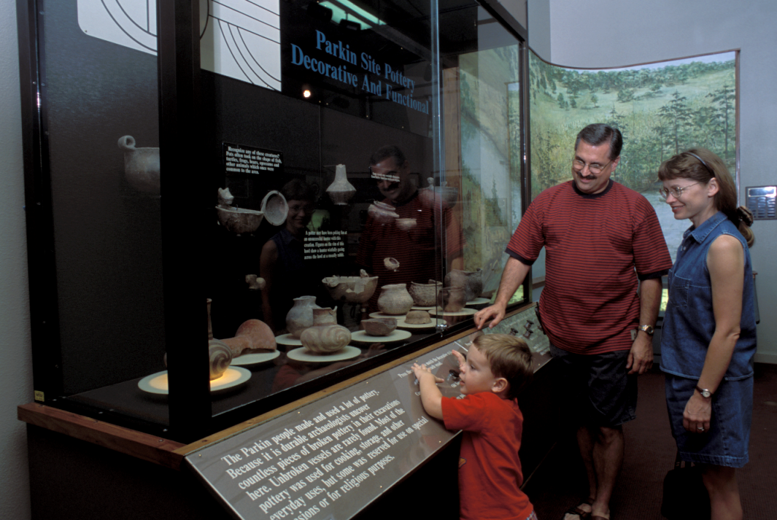
Interpretive exhibits are displays comprised of text, illustrations, photographs, audiovisual aids, and/or three-dimensional components. Many state-of-the art exhibits include hands-on interaction. Exhibits may be permanent to a location or temporary displays, such as traveling and suitcase exhibits.

Advantages:
- Can build in interactive components
- Effective in conveying major themes and sub-themes
- Provide diverse means for telling stories
- Normally attractive and interesting
- Effective in educating children

Disadvantages:

- Can be expensive to produce
- Must be indoors in most cases
- May not be available at all times
- Require ongoing maintenance

Considerations:

- Can the story best be conveyed through a three-dimensional medium?
- Will the exhibit be indoors or outdoors and, depending on location, what environmental factors will need to be considered?
- Who will maintain the exhibit? Will the exhibit be sturdy enough to survive hands-on interaction?
- Does the exhibit design complement the story being told?
- Does the exhibit tell a story, rather than just giving facts and information?
3/3

Festivals

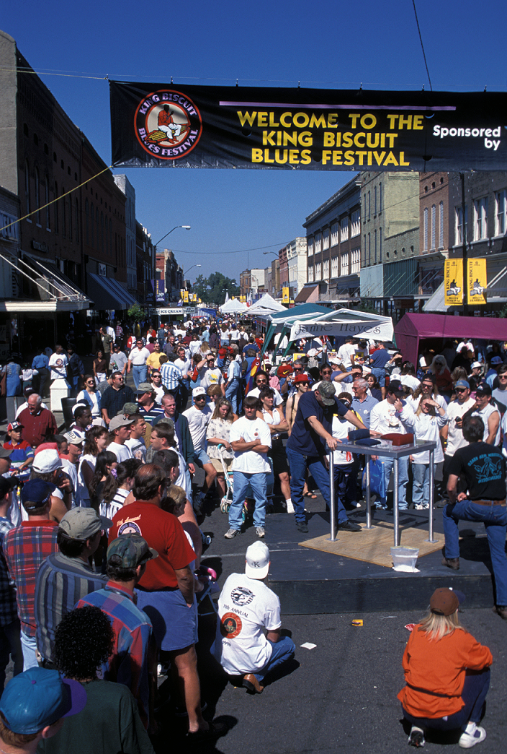
Festivals are an excellent way to convey information about the cultural heritage of a particular region or ethnic group. In addition to games and entertainment, they can convey the music, food, lifestyles and other characteristics of the region or the occasion.

Advantages:

- Provide activities and entertainment for the entire family
- Convey the flavor of a community and its culture through a variety of methods
- Can bring communities together through the planning process

Disadvantages:

- Generally held only once a year, requiring visitors to schedule accordingly
- Success often largely dependent on uncontrollable factors such as weather conditions
- Can be expensive to produce

Considerations:

- Are sufficient community resources and volunteers available for putting on such an event?
- Are resources being interpreted best related to a specific time of year?
- Can area accommodate the number of visitors that would be attracted to a festival?
- Are there adequate means of attracting visitors for the specific dates of the festival?

3/4
Guided Tours

Guided tours involve a staff person or volunteer leading the way through an attraction and providing commentary. Tours might be through a series of locations, a series of exhibits within a location, a house museum, a specialized facility, or any number of other attractions.

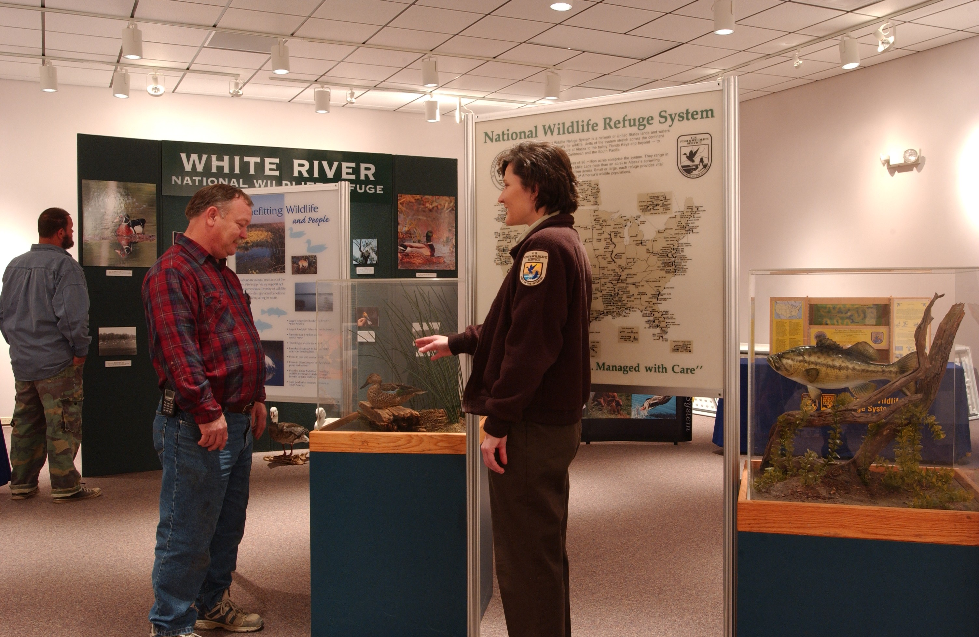
Advantages:

- Provide direct interaction with visitors and can readily address questions
- Can give more in-depth information about an attraction
- Can be altered to fit specific audiences and interests

Disadvantages:

- Can be expensive unless guides are volunteers
- Guides must be adequately trained
- Require proper scheduling to ensure a sufficient number of guides at times tours are offered

Considerations:

- Are there a number of stories that can be told about an attraction, depending on audience interests?
- Are adequate training procedures in place?
- Will guides present in first person or third person (acting out a character versus passing along information)?
- Is someone available to handle scheduling?
- Does nature of attraction require the presence of a guide at all times?
3/5
Interpretive Centers
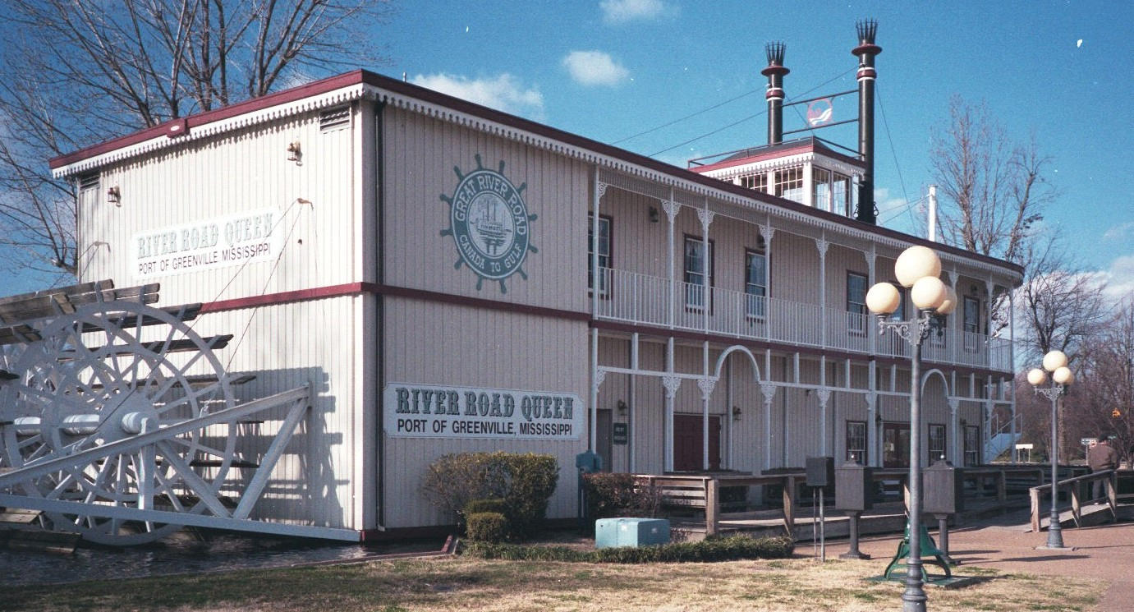
Interpretive centers generally house exhibits related to a specific theme within a centrally located building. In addition, they may offer self-guided trails, interpretive signs and publications, tours, presentations, special events, and numerous other activities.

Advantages:

- Appeal to visitors of all ages and learning styles
- Tell comprehensive stories through a variety of media
- Serve as a major visitor destination, thus boosting the local economy
- Provide a central location for interpreting related local resources and stories

Disadvantages:

- Normally open only during certain hours
- Generally require staffing which can be expensive
- Can be costly to build, operate and maintain

Considerations:

- Do the resources in the area have enough visitor appeal to justify construction of an interpretive center?
- Would an interpretive center make local resources more attractive to visitors?
- Is there public support for this effort?
- Is there an appropriate agency or organization responsible for developing and operating the center?
- Will the building itself complement and enhance the stories being told?

3/6
Interpretive Staff

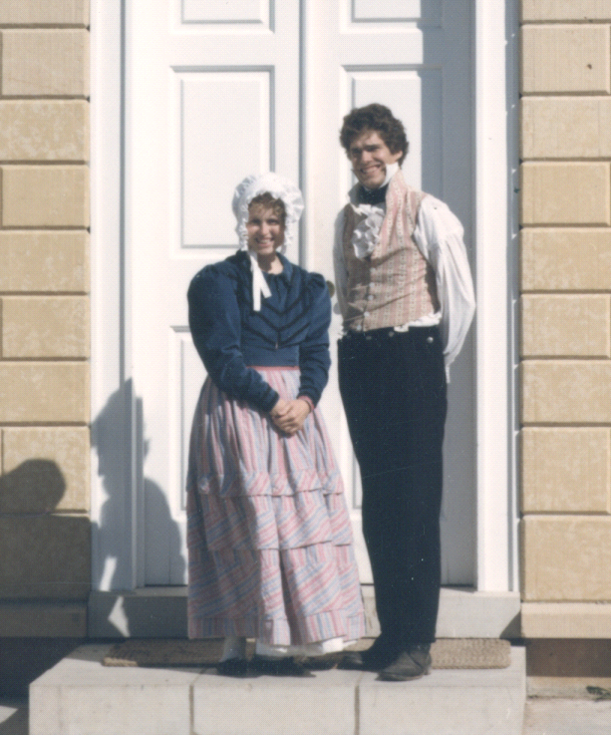Staff interpreters may be volunteers or paid staff who convey information to visitors through first person or third person methods. First person interpreters act out and dress the part of the person they are interpreting. Third person interpreters provide information to visitors without portraying another person.

Advantages:

- Can alter presentations and information for specific audiences
- Allows for one-on-one interaction and answering questions
- Can motivate visitors to experience activities they might not otherwise participate in on their own

Disadvantages:

- Can be expensive unless volunteers are available
- Must be trained
- Must be available at all hours they are needed

Considerations:

- Will the information be presented in first person or third person?
- Will interpreters be used for special presentations and tours only, or will they have additional responsibilities?
- Will you use professionally trained and educated interpreters or volunteers?

If you use volunteers, who will do the training?
3/7

Presentations/Lectures

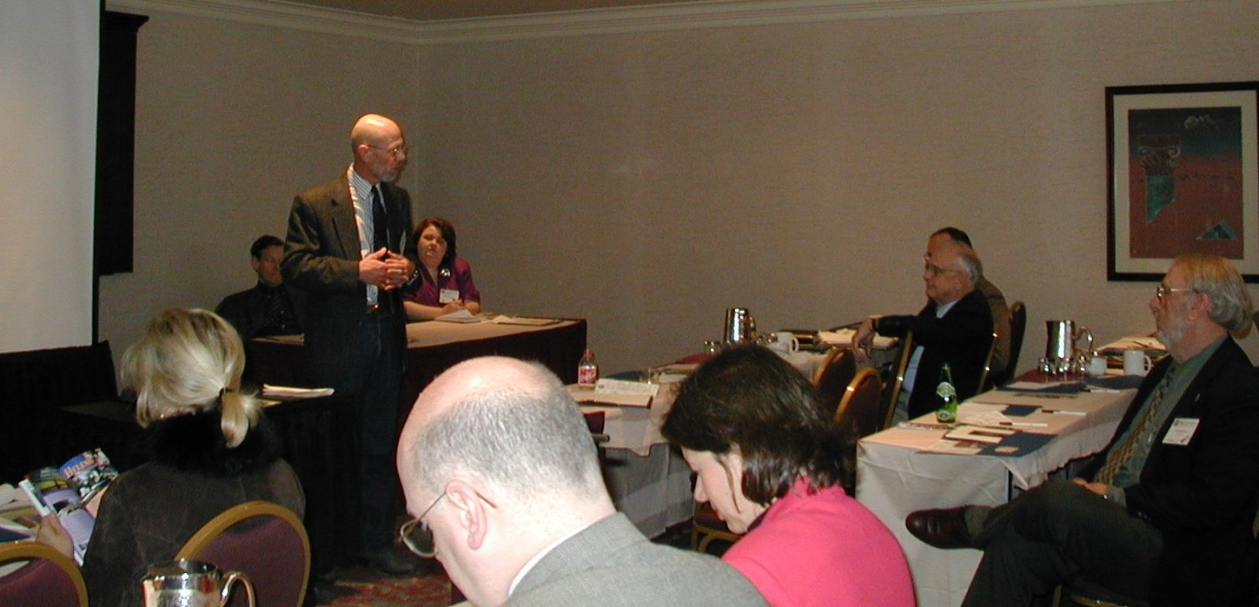
Presentations and lectures provide in-depth information on a particular topic related to the main theme or one of the sub-themes of an attraction or local resource.

Advantages:

- Can orient visitors to the site or local resource
- Can present specific information on a special topic
- Can provide context and background for visitors

Disadvantages:

- Require staff preparation time or costs of bringing in outside speakers
- Visitors are locked into the time schedule set for the lecture.

Considerations:

- Does presentation topic have sufficient interest to attract an audience?
- Is there a place suitable for the presentation?
- Does speaker have sufficient knowledge of topic?

3/8
Publications

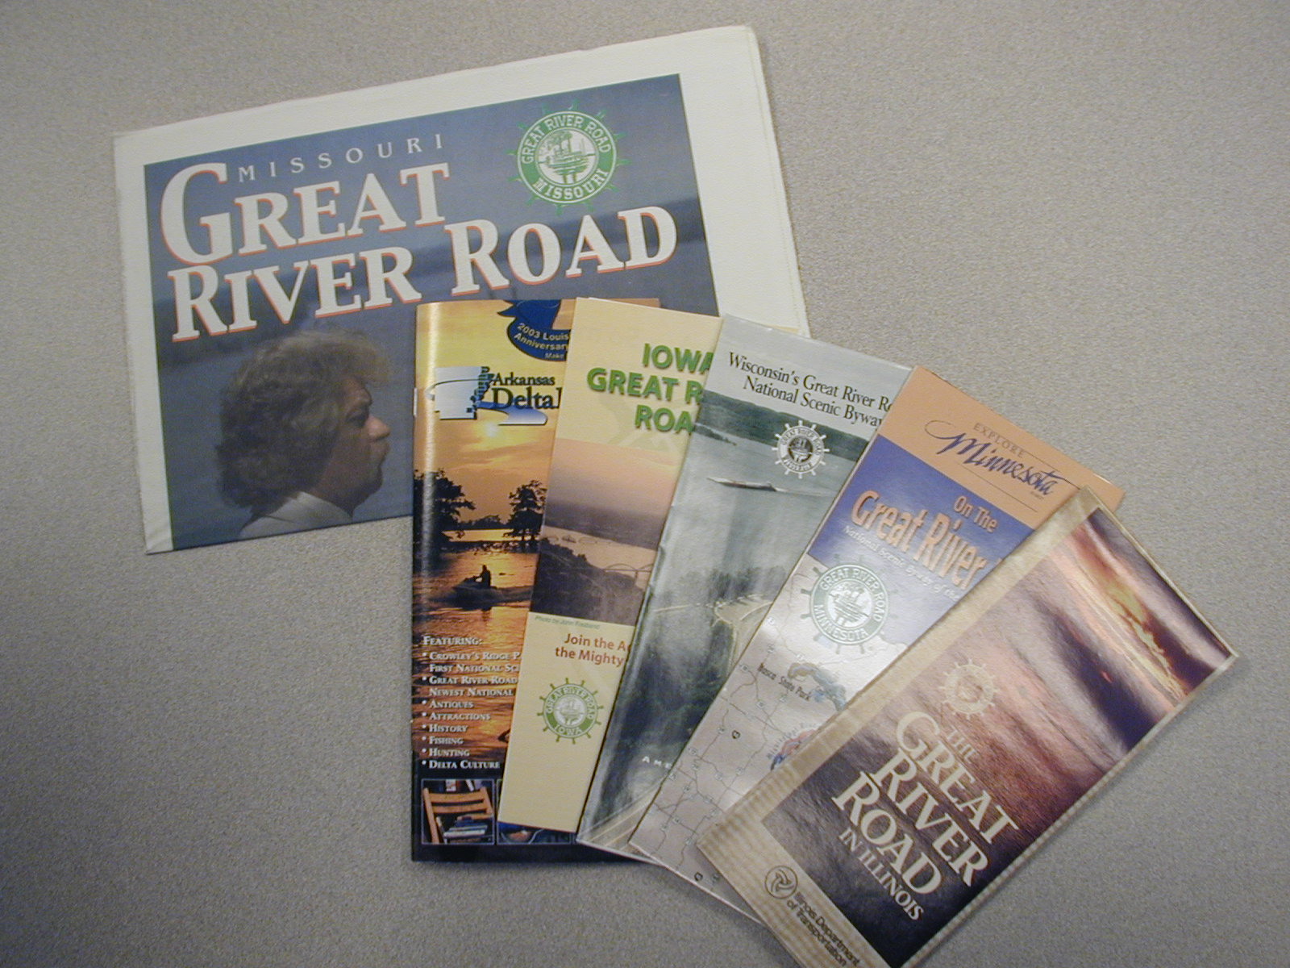
Publications can be such materials as guidebooks and maps that move visitors from one attraction to another, or brochures that interpret information about a single attraction. Unlike tourism publications designed to entice people to visit or to list available attractions and resources, interpretive publications provide specific information about the resources and/or attractions.

Advantages:

- Relatively inexpensive to produce
- Generally convey great amount of information
- Easily carried and distributed
- Can be mailed to prospective visitors before arrival at the site
- Can communicate different themes tailored to different visitor groups

Disadvantages:

- Not always easy to update
- May not be readily available to visitors and potential visitors
- Typically must be used in conjunction with other interpretive methods
- Rely on visitors being able and interested enough to read

Considerations:

- How will information be disseminated? (This will influence size)
- Does information need to be available at all times of day? And if so, how will that be accomplished?
- Would it be helpful for visitors to have additional detailed information to take away with them?
- Would having information about the site in advance enhance visitors’ interest and experience?

3/9
Radio Transmissions

Low-powered AM radio transmissions, also called Traveler Information Sources (TIS), are sometimes used at specific attractions and in communities to interpret information to visitors and orient them to an area. Depending on the amount of transmitter power, such stations generally can broadcast over a range from 0.5 to 2.5 miles.

Advantages:

- Great for driving tours within short distances
- Can provide up-to-date information
- Can be programmed easily
- Do not require FCC licensing, meaning greater programming flexibility

Disadvantages:

- Visitors must be in their vehicles or within radio range
- Messages cannot be transmitted over long distances
- Initial costs for station construction and equipment purchase are high
- Staff time is required to update the transmission frequently

Considerations:

- Is the area small enough to make effective use of radio transmissions?
- Is someone available to keep information updated?
- What type of information will be conveyed?
- How will different messages be sequenced for transmission?

3/10
Recorded Messages

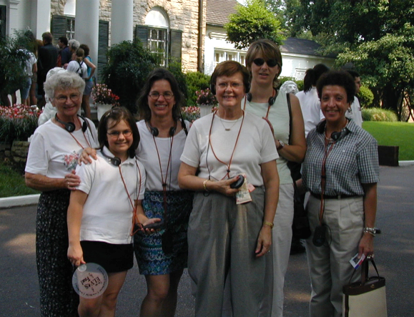Using recorded messages as part of an exhibit or as part of a self-guided tour is increasing in popularity. Such messages are generally cassette tapes or compact disks.

Advantages:

- Can be extremely effective for self-guided tours
- An effective method for interpreting to visually impaired audiences
- Can be used effectively to convey stories, anecdotes and quotes
- Effective in both small areas (such as an exhibit in an interpretive center) or large areas (such as an entire byway)
- Motorists generally have either cassette or compact disk players in their vehicles

Disadvantages:

- If used in an interpretive center, must include ear-sets or other methods to avoid disturbing other visitors
- If used outside an interpretive center, must have effective distribution method for lending and retrieving the recordings
- Initial investment can be costly

Considerations:

- Are themes best communicated through stories, quotes and anecdotes?
- How will recorded messages be distributed, and what incentives will be provided for return of equipment and/or recordings?
- Who will be responsible for maintaining equipment?
- Who will produce recordings?
3/11
Reenactments/Living History

Reenactments and living history provide information about a time, place, person, or event through first-person characters that reenact an actual event or act out a simulated event that provides well-researched insights into a time, place or person.
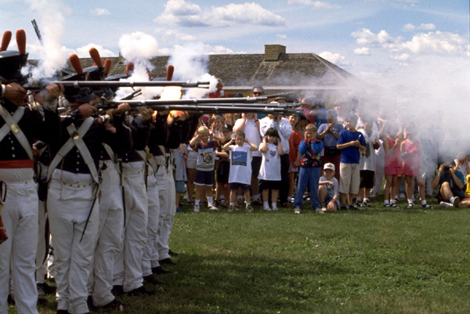
Advantages:

- Can be extremely interesting and entertaining
- Can go into detail about a specific time, place, person, or event
- Can engage audience in unique ways

Disadvantages:

- Limited to perspectives of characters being portrayed
- Require in-depth research, training, and costuming for characters being portrayed
- Audience interaction may be limited by need to stay in character

Considerations:

- Is event or time period being portrayed best explained by acting it out?
- Are people available with sufficient acting background or stage presence to carry out a role?
- How will reenactments be scheduled for maximum audience
- Can event/time period, etc. being presented be researched adequately enough to present an accurate scenario?
3/12
Self-Guided Tours

Self-guided tours enable visitors to follow along a series of exhibits or attractions at their own pace, generally accompanied by a printed brochure or an audio recording to move them from point to point.

Advantages:

- Allow visitors to spend as much time as desired at each attraction
- Can include printed materials (such as a brochure) or an audio device (such as a cassette tape or CD)
- An effective way to relate a series of attractions in different locations

Disadvantages:

- Often a challenge to provide clear and readable directional signs
- Guide publications, recordings or signage must be precise without being wordy
- Opportunities limited for asking questions or getting additional information

Considerations:

- Are there a number of related attractions or resources that can be tied together to create a tour?
- Are visitors provided with adequate instructions for moving from one exhibit or attraction to the next?
- What kind of materials (such as brochure, signage, recordings, etc.) do visitors need to aid in understanding the exhibit or attraction?
3/13
Signage

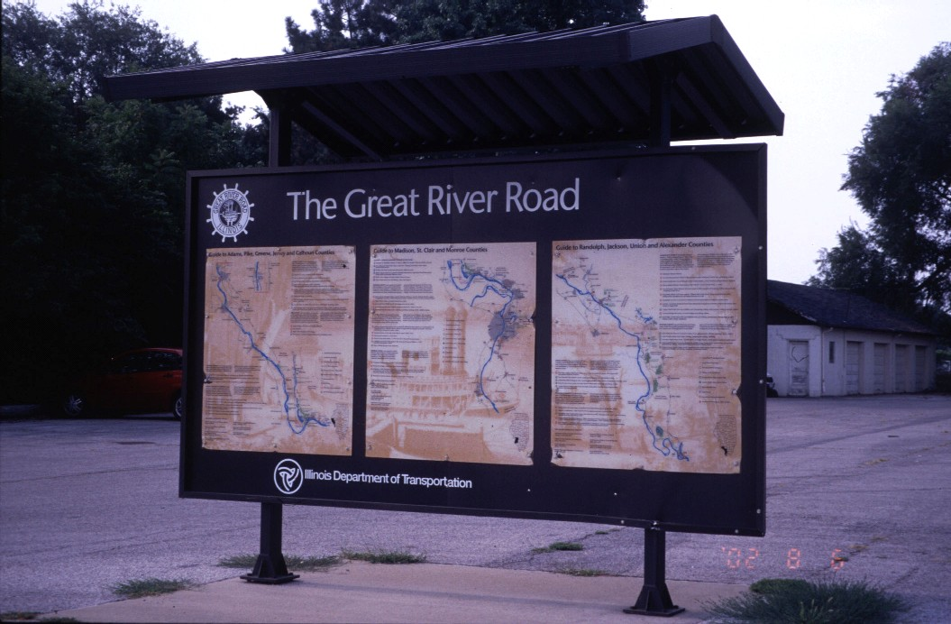
Signage generally refers to one or more panels on which a resource is interpreted through text, photographs, illustrations and/or three-dimensional components. Such signs are mounted on displays that physically anchor them to a specific site.

Advantages:

- Can be utilized indoors or outdoors
- Provide continuous information at all hours when used outside
- Good at catching people’s attention
- Excellent for marking specific spots of interest along a route

Disadvantages:

- Can be expensive to design, install and maintain
- Subject to vandalism and/or environmental deterioration
- Limited space for conveying a message
- Require adequate pullovers for vehicles to stop

Considerations:

- Does information need to be available to visitors at all times of day?
- What kind of maintenance will be required and who will be responsible?
- Will all visitor groups be able to use the sign (including children and physically disabled)?
- Is the sign material suited to local environmental factors and resistant to vandalism?
- Will the sign complement landscape features?
- Is signage as close as advisable to the resource being interpreted?

3/14
Slide Presentations

Slide presentations are primarily visual statements that can be prepared as traditional slides or through computer-generated programs such as PowerPoint. They may be programmed to operate automatically with a sound track or recorded script, or slides can be advanced manually by a presenter or by the visitor.

Advantages:

- Can be developed and modified quickly and easily
- Relatively inexpensive
- Can stand on their own or be used with a presenter
- Can be carried to different locations

Disadvantages:

- Require an initial investment in equipment
- Often depend on adequate room lighting

Considerations:

- How will presentation be operated? By a presenter? By the visitor? Automatically?
- Can equipment be set up properly without being intrusive?
- Is room suited to a slide presentation?
3/15
Special Events

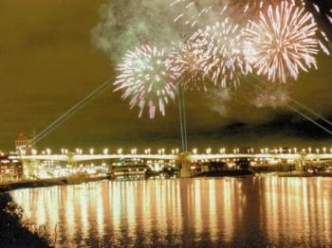
Special events are programs and activities scheduled to expand upon a theme or a sub-theme. These may be annual or one-time events or celebrations. Such events may be keyed to a special date of importance or to special topics related to stories being told at a site.

Advantages:

- Can be tailored to specific resources or attractions
- Offer great opportunities for creativity
- Can be designed to fit a budget

Disadvantages:

- Require adequate promotion to get people to attend
- Require concentrated staff and volunteer time to produce

Considerations:

- Can a program be designed that is both informative and entertaining?
- Is there something unique that is worth celebrating?
- Are there logical audiences to be invited to the event?
- How will the event be promoted and publicized?

3/16
Video

Video presentations make effective use of both site and sound. They can be used in a number of formats, such as a theater, a classroom, a component of an interpretive exhibit, a civic club presentation, etc.

Advantages:

- Provides excellent visuals
- Requires little involvement from interpretive staff for videos with soundtrack
- Easy to move to different locations
- Projects a large size image
- Can show visitors a facility without making an actual tour, making them effective for visitors with mobility impairments.

Disadvantages:

- Expensive to produce
- Cannot be easily updated
- Often available only when interpretive centers are open or staff available
- Equipment can be expensive to purchase and maintain

Considerations:

- Is the information to be conveyed best interpreted through both sight and sound?
- Where will the presentation be used? How will this affect its length?
- Who will maintain the equipment?
- Will it require a staff member, or can a visitor start it by pushing a button?
3/17
World Wide Web

The World Wide Web offers a variety of interpretive opportunities. Sites can either serve primarily to promote and provide information for prospective visitors or they can provide “virtual tours” for those who are unable to travel to the actual facility.

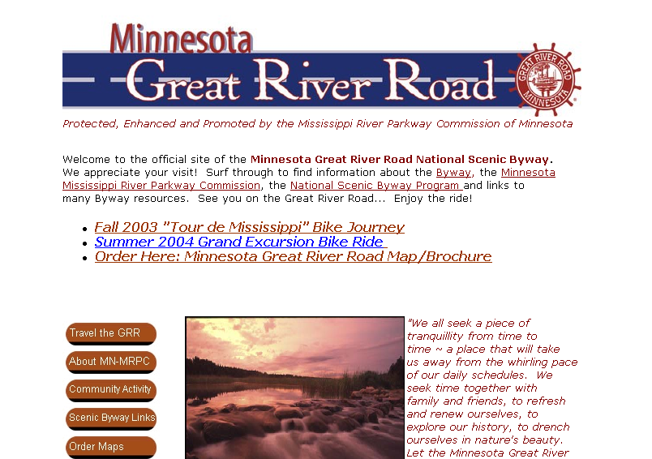Advantages:

- Widely accessible to people in their own homes
- Relatively easy and inexpensive to develop
- Excellent for sharing attractions with people who cannot come to the actual site
- Provides easy means for evaluating number of visitors to a site.
- 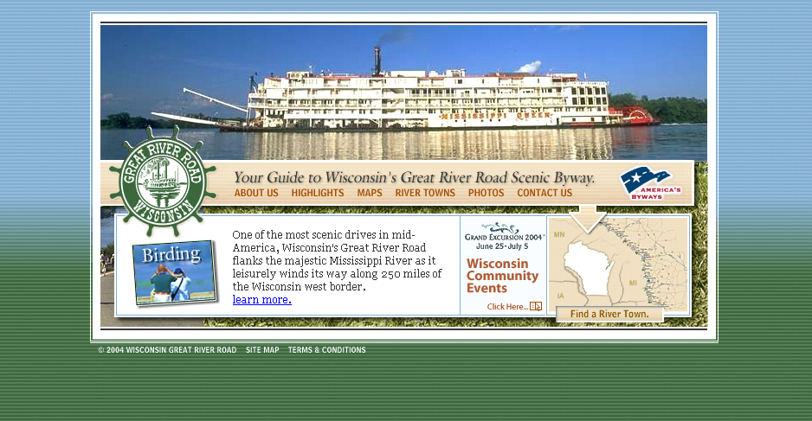Can be made interactive, including ordering tickets, making reservations, etc.

Disadvantages:

- Requires computer literacy on the part of potential users
- Does not provide firsthand experience
- Access through an on-line service can be expensive
- Requires staff or consultant expertise for designing pages and creating interactive sites
- Requires someone to keep the site updated on a regular basis

Considerations:

- Will a staff person be available to monitor the site on a regular basis?
- Will the site be used for educational or promotional purposes?
- Will use of a site help your facility meet its goals?
3/18

DO NOT COPY THIS PAGE. IT IS HERE SINCE A DIVIDER WILL BE PUT IN ITS PLACE.

Visitor Profiles
U. S. Domestic Travelers

47 years - average age of Household Head*
- Marital Status
  - 64% married
  - 19% single/never married
  - 17% divorced, widowed, separated
- 55% of Household Heads* have a college degree, including 19% with graduate work started or completed
- 39% of Household Heads* have a managerial or professional occupation
- 36% have children in the household
- Annual household income: $68,200 mean, $56,600 median**
- Households
  - 21% have one person
  - 36% have two people
- 77% own a home/19% rent
- 82% own a personal computer
- Life-stage
  - 39% couples
  - 35% parents
  - 26% singles

- If there is both a male and female head of household, then the male head of household is used.
- ** Median is the point where one-half of traveling families earn more and one-half earns less.

U. S. Domestic Travelers—Other Trends

Leisure travel accounts for the majority (77%) of all U.S. domestic travel. Leisure travel includes visits to friends and relatives, as well as travel for outdoor recreation, entertainment and personal reasons.

Travel for general business purposes (likely for meetings, presentations, consulting, sales, etc.) or to attend a convention or seminar accounts for 12 percent of all domestic person-trips (or 122 million). Travel that combines business with pleasure accounts for eight percent of all U.S. domestic person-trips (or 75.5 million).

Overnight trips account for 85 percent of person-trips. Short trips of one to two nights are more popular than trips of three to six nights or seven nights or more. Over half (55%) of all overnight household trips include lodging at a hotel, motel, or bed and breakfast establishment. Among overnight leisure household trips, staying with friends or relatives is more popular than lodging in a hotel, motel, or bed and breakfast establishment.
3/19

Of 11 common trip activities, the most popular is shopping, included on one-third (34%) of all person-trips. Engaging in outdoor activities (17%) and visiting historical places/museums (14%) are also quite popular trip activities.

Summer is the most popular travel season, accounting for one-third (32%) of person-trips. A similar share of travel occurs in the fall (24%), as in the spring (23%). Winter is the least popular season of travel (21%).

One quarter (24%) U.S. domestic household trips included children. As expected, leisure household trips more often include children than combined business/pleasure trips.

Nearly half of person-trips are taken to destinations within the traveler’s state of residence. Three in ten person-trips are taken to destinations that are out of the traveler’s state, yet still within their census division. One third of travel is out of their census division of residence. While the majority of trips include one destination, some include multiple destinations.

Trips are most often taken by households residing in major cities or Metropolitan Statistical Areas (MSAs) of 2 million people or more.

Most trips are taken by households that own their home. Most trips are taken by households that own personal computers and a majority of trips are made by households that own cellular phones. Thirteen percent of trips are generated by households that own an RV.

Compared to demographics of all U.S. households, traveling households are more likely to be married. Households taking trips also tend to be more highly educated and are more apt to be employed full-time. Consequently, households taking trips tend to have higher average annual household incomes. Moreover, home ownership is also higher for households who take trips compared to overall households. Interestingly, households that travel are much more apt to own a personal computer than are all households.

Source: Domestic Travel Market Report, 2003 Edition; Travel Industry Association of America
3/20
Automobile Travelers

- Profile of 2003 Auto person-trips/Auto travelers:
  - 47 years old, average age
  - $53,400 is the median annual household income
  - 66% are married
  - Purpose
    - 83% leisure
    - 7% business, convention, seminar
    - 7% combined business, pleasure as main purpose
  - 3.5 nights, average duration of trip
  - Lodging
    - 49% in hotel, motel, B&B
    - 43% in the home of a friend or relative
    - 5% in condos or timeshares
    - 5% in RVs or tents
  - Household
    - 35% one person from household on trip
    - 36% two household members on trip
  - $317 average spending on trip
  - 29% include children
  - Activities
    - 34% shopping
    - 18% outdoor
    - 12% historical places, museums
  - Seasons
    - 33% summer
    - 24% fall
    - 23% spring
    - 20% winter
  - Destination
    - 47% in-state trips
    - 24% in-census division trips
    - 29% out-of-census division trips
3/21

- Auto travel person-trips have grown 11 percent since 1994, increasing from 725.2 million person-trips to 802.2 million person-trips in 2002. In 2002, the share of auto person–trips was up two percentage points from 2001. Consequently, the share of air person-trips was down two percentage points during this timeframe.

- Auto travel – including travel by truck and recreational vehicle – accounts for the majority (75%) of travel in the US, registering 772 million person-trips. Air travel, on the other hand, accounts for 16 percent of travel in the U.S., registering 161.9 million person-trips. A larger share of business/convention person-trips than combined business/pleasure person-trips are taken by air.

- Nine in ten (94%) auto person-trips are taken by a personally owned car or truck. Smaller shares of auto person-trips include a rental car (4%) as a primary mode of transportation or are taken by camper/RV (2%).

- Four in ten (44%) owned car/truck person-trips are taken to visit friends or relatives. Eight in ten (83%) car/truck person-trips involve an overnight stay. Owned car/truck traveling households primarily lodge at hotels, motels, or bed and breakfast establishments, accounting for half (49%) of overnight household trips, followed by a stay at a home of friends or relatives (43%).

- On average households spend $317 per car/truck trip versus $457 for the average domestic trip overall, not including transportation to the destination.

- Shopping accounts for one third (34%) of owned car/truck person-trips. Engaging in outdoor activities (18%) and visiting historical places or museums (12%) are the next most popular activities.

- Three in ten owned car/truck (29%) household trips include children from the household.

- Four in ten (43%) owned car/truck trips are taken by household headed by someone age 35 to 54. Half (52%) of household generating owned car/truck trips are headed by someone with a college degree or more and one third (31%) by households with an annual income of $75,000 or more.

Sources: Auto Travel in the U.S., 2003 Edition; Travel Industry Association of America
3/22
Business and Convention Travelers

- Travel for business purposes accounts for twenty percent of all U.S. domestic person-trips. This includes travel for general business purposes (meetings, presentations, consulting, sales, etc.) travel to attend a convention or seminar and travel combining business and pleasure.

- 2002 was the fourth straight year that business/convention/seminar travel volume has declined. There were 122 million person-trips.

- Travelers taking business trips tend to drive their own car or truck (46%). 38 percent of business travel includes air transportation. About twelve percent include a rental car as a secondary mode of transportation.

- Most business trips involve an overnight stay. For business travelers who stay overnight in any form of lodging, the trip lasts an average of 3.1 nights. Away from home, business travelers primarily lodge at hotels, motels, or bed and breakfast establishments (91%). Five percent stay in the home of a friend or relative.

- On average, business travelers spend a total of $516 per household trip, excluding transportation to their destination.

- The majority of business trips are taken by solo travelers (84%). Eleven percent include two household members on the trip. Four percent include children from the household.

- Business trips tend to be taken by individuals in households that are married and between the ages of 35 and 54. They also tend to have a college degree and be employed in a professional or managerial capacity. Their median annual household income is $87,200.

Source: Domestic Travel Market Report, 2003 Edition; Travel Industry Association of America

3/23
E-Travel Consumers

- Approximately, 54 percent of the 211.6 million adults in the U.S. currently use the Internet, the same proportion as in 2002. This translates to 114 million adults. Internet penetration among U.S. adults is no longer experiencing the rapid growth seen in the late 1990s and may have seen its plateau in 2002.

- 84% of the 114 million adults who currently use the Internet indicate they are travelers, meaning they have taken at least one trip of 50 miles or more away from home in the past year, not including daily commuting. This translates to a market of 95.8 million travelers who use the Internet, or online travelers.

- Among the 144.4 million U.S. travelers today, 66 percent use the Internet. Frequent travelers taking five or more trips annually, have an even higher likelihood of using the Internet (74%).

- As growth in the number of online travelers has slowed, so has the number of online travelers who actually use the Internet for travel planning. Similar to 2002, a majority (67%) of online travelers say they consulted the Internet to get information on destinations or to check prices or schedules in 2003. This translates to 64 million online travel planners, or 30 percent of the U.S. adult population.

- Nearly half of those planning trips online say they do most or all of their travel planning on the Internet, compared to 42 percent in 2002. Online travel agency websites (such as Microsoft Expedia, Travelocity, or Priceline), search engine websites, and company-owned websites (airlines, hotels, etc.) continue to be the most popular types of websites used. Just over half of online travel planners also use destination websites to plan their trips.

- Online travel planners do a variety of trip planning activities on the Internet. Searching for maps or driving directions and looking for places to stay became more popular in 2003, but fewer online travel planners searched for airline schedules and fares. Destination-related searches, such as searching for things to do, dining, entertainment, and local events, were also more popular in 2003.

- 66% of online travel planners, or four in ten (44%) online travelers, are booking or making travel reservations online. This may include booking an airline ticket, hotel room, rental car or package tour online. Today, there are 42.2 million online travel bookers.

Source: Travelers’ Use of the Internet, 2003 Edition; Travel Industry of Association of America
3/24
Family groups

- Parents are more likely than other travelers to travel during the summer when the kids are out of school (July and August), drive their own vehicle to their destination, participate in outdoor activities and visit theme or amusement parks.

- Young parents are somewhat more likely than middle parents to have a college degree or a managerial/professional occupation. But the two groups have similar household incomes.

- Older parents represent a composite of several life-stages. For example, older parents mirror other parents in that they take more trips during July and August. Older parents more often stay in a hotel, motel or bed and breakfast, and spend $500 or more while on their trip.

Source: Domestic Travel Market Report, 2002 Edition; Travel Industry Association of America

3/25
Gambling Travelers

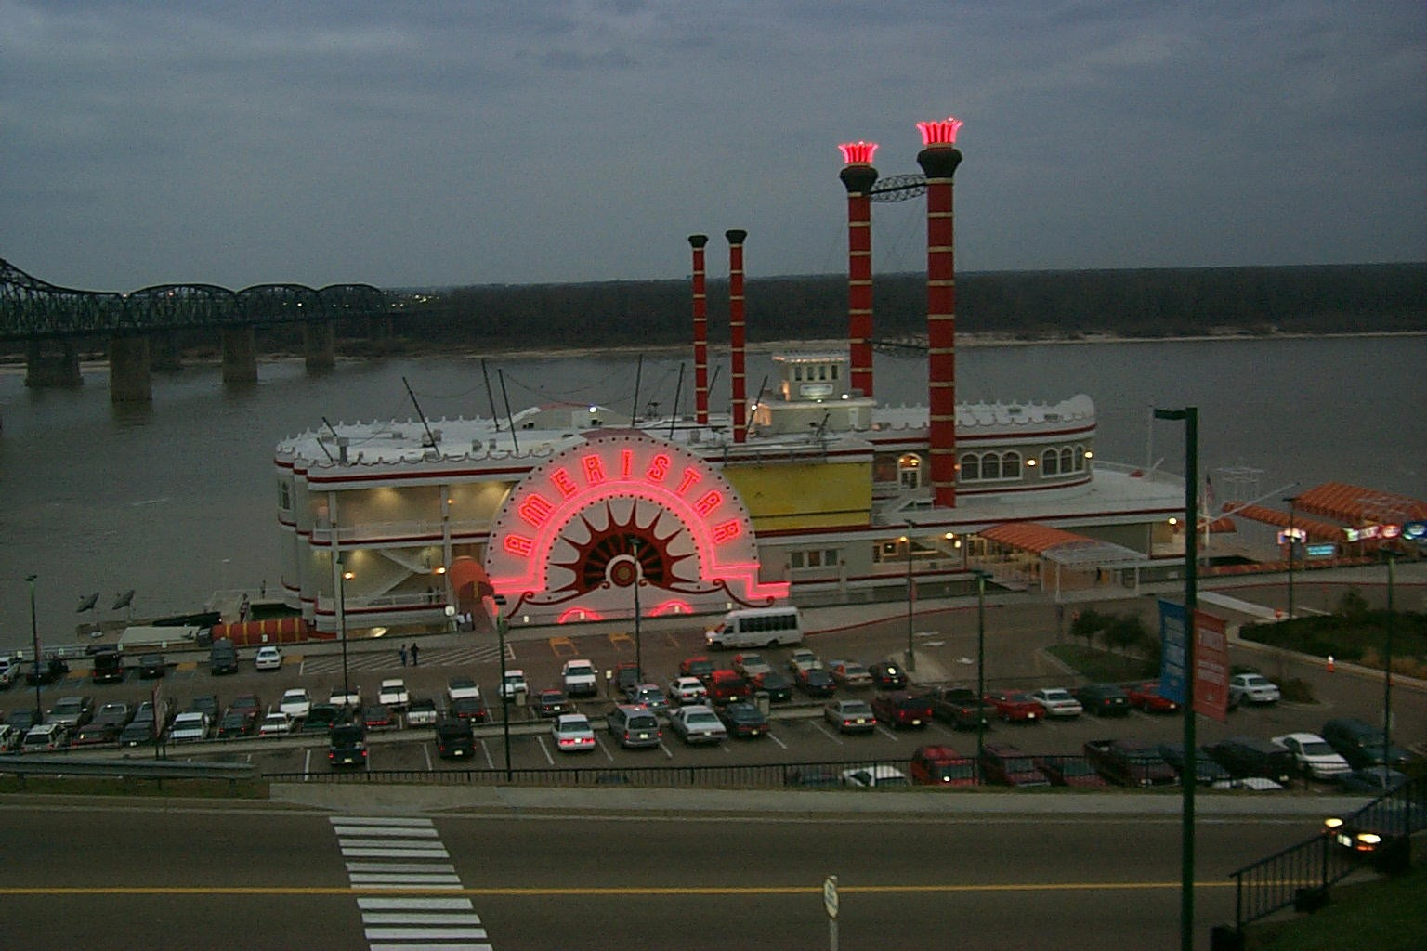
- Like most travelers in the U. S., leisure purposes dominate the travel plans of gambling travelers. Gambling travelers, however, are three times more likely than average to travel for entertainment. Only thirteen percent of gambling travelers cite business as the main purpose of trip, a lower share than the average U. S. traveler. Gambling travelers also are more likely than U. S. travelers overall to travel by air, include a stay at a hotel, motel, or bed and breakfast establishment, and have higher trip spending levels.

- Similar to all U. S. travelers, shopping is the most popular trip activity for gambling travelers, accounting for one-third of person-trips that include gambling. Notably, nightlife is twice as popular for gambling travelers than travelers overall, while outdoor recreation is much less popular.

- Households taking gambling trips tend to be 55 years of age and older with an average age of 51. 41% have a college degree or more education. 57% are married and 23% have children at home.

- Gambling-only travelers--those indicating that gambling is the only trip activity from a list of 11 common activities - take 43 percent of all U. S. domestic gambling person-trips. Multi-activity travelers-travelers participating in gambling and other trip activities-take 57 percent of all gambling person-trips.

- More gambling-only travelers than multi-activity travelers cite entertainment as the primary purpose of trip and travel by their own auto or truck or by bus. On the other hand, greater shares of multi-activity travelers visit friends or relatives or travel for outdoor recreation. And multi-activity travelers more often include air travel as their primary mode of transportation and use of a rental car as a secondary mode of transportation.

Source: Profile of Travelers Who Participate in Gambling, 2000 Edition; Travel Industry Association of America
Domestic Travel Market Report, 2002 Edition; Travel Industry Association of America
3/26
Historic/Cultural Travelers

- 81 percent of U.S. adults who took at least one trip of 50 miles or more, one-way, away from home in the past year included at least one cultural, arts, historic or heritage activity or event on the trip. This represents 118.1 million adult historic/cultural travelers. These historic/cultural traveling households took over 216.8 million historic/cultural person-trips in 2002 (one person-trip equals one person on one trip 50 miles or more, one-way, away from home or including an overnight stay) or one in five (21%) of all domestic person-trips. One quarter of historic/cultural travelers are frequent historic/cultural travelers taking three or more of these trips a year.

- Nearly half of adults who traveled in the past year report they attended a performing arts event during any past-year trips. Four in ten adults who traveled in the past year report they visited a designated historic site, such as a building, landmark, home or monument.

- Most trips with historic/cultural activities are for leisure purposes and are by car or truck; one in five trips includes air transportation. Nearly all historic/cultural person-trips involve an overnight stay. For those staying overnight, the trip lasts an average of 5.2 nights and most often include a stay at hotels, motels, or bed and breakfast establishments.

- Four in ten historic/cultural trips are taken by Baby Boomer households (age 35-54). Six in ten trips are generated by households with a college degree, and one third by households with an annual household income of $75,000 or more. One third of trips are generated by households with children.

- Three in ten historic/cultural travelers say the destination of their most recent trip was influenced by a specific cultural/historic activity. One in five say the timing of their most recent trip was influenced by such activities at the destination.

- One in five say they planned the activities both before the trip and at the destination. Four in ten say they added extra time to their trip because of an historic/cultural activity.

Source: Domestic Travel Market Report, 2003 Edition; Travel Industry Association of America
3/27

Mature Travelers

- One of the most important demographic trends affecting the travel industry today is the aging of the U. S. population. In the year 2001, the first members of the huge Baby Boom generation (78 million) turned 55 years old and entered their "mature" years.

- When it comes to annual household income, Mature travelers have the highest net worth of all age groups. Their discretionary income is also very high since they no longer incur the cost of setting up a household or raising children. They also have lower consumer debt than other population segments. The financial power of Mature consumers, along with their tendency to have more leisure time available for travel, make this segment one of particular interest to the U. S. travel industry.

- The Mature market is already quite large, accounting for nearly one-third of all domestic travel in the U. S. Furthermore, this market will grow significantly in size over the next two decades. To reach this important market in the coming years, marketing messages will likely shift from a youth-oriented focus to a greater concern for the needs, problems, and dreams of middle-aged and older adults.

- Most trips taken by Mature travelers continue to be pleasure trips by auto. Half of trips by Matures include lodging in hotels, motels, or bed and breakfast establishments and four in ten trips include lodging in homes of friends or relatives.

- The demographic profile of Mature travelers has shifted dramatically over the past five years. Many more trips are taken by Mature travelers who have completed college and have an annual household income of $75,000 or more. Today, Mature travelers are also more technologically savvy than they were five years ago.

- Shopping is the favorite activity on trips by Matures; in fact, three in ten Mature trips include shopping. Other preferred trip activities involve visiting historical places or museums, attending cultural events or festivals, gambling, and outdoor activities. Trips by Matures are more likely than trips by younger age groups to involve cultural events or festivals, visits to historical places, gambling, and group tours.

- Senior Matures, those aged 65 or older, generate 16 percent (92.6 million) of all U.S. domestic trips. Junior Matures, those aged 55-64, take 15 percent (86.2 million) of all U. S. domestic trips.
3/28
- Junior Mature trips are more apt than Senior Mature trips to include shopping, outdoor activities, nightlife activities, and visits to theme or amusement parks. But, Senior Mature trips are more likely to involve visiting historical places or museums, attending cultural events or festivals, and group tours.

- Four in five Mature trips include an overnight stay (79%); the remainder are day trips. Overnight trips are more likely than day trips to include visits to friends or relatives. Not surprisingly, spending by Matures on overnight trips is higher than spending on day trips. Mature overnight trips are more likely to include shopping and visiting historical places or museums. Interestingly, group tours are twice as popular on day trips than overnight trips. Day trips are just as likely as overnight trips to include gambling and attending sports events.

- About two-thirds of all trips by Mature travelers are taken by those who are married (64%). The rest of the trips are taken by those who are never married (6%) or divorced, widowed, or separated (30%). Trips by single Mature travelers are more likely than those taken by married travelers to be for pleasure and involve bus travel. On the contrary, trips by married Matures are more apt to be for business and include travel by car, truck, or recreational vehicle.

- Gambling as a trip activity is more popular on trips taken by retired Matures versus those who are still working. Group tours are nearly three times as popular on trips by retired Matures than on those by employed Matures.

- About half (48%) of Mature traveling households own a personal computer. Not surprisingly, most Mature PC owners are Junior Matures aged 55-64. Trips by Mature travelers who own PCs are more likely than those taken by non-owners to be for business and consequently, to include air transportation and a rental car as a secondary mode of transportation. Conversely, trips by Matures who do not own a PC are more often for pleasure.

- PC owner trips are more likely than non-owner trips to include outdoor activities and golf, tennis, or skiing. However, non-owner trips are more apt to involve gambling and group tours.

Source: The Mature Traveler, 2000 Edition; Travel Industry Association of America
3/29
Minority Travelers

- U. S. travelers, regardless of race or ethnicity, behave similarly in many ways. The profiles of African-American, Hispanic, and Asian-American travelers mirror those of all U. S. travelers on many key travel behaviors and demographic characteristics. Other travel behaviors, however, do vary significantly by ethnic group.

- In any given month during 1999, on average, a quarter of African-American (26%) and Hispanic (27%) households report taking a trip, resulting in an estimated 69.6 million and 71.2 million person-trips annually, respectively. Four in ten (42%) Asian-Americans report taking a trip on average each month, resulting in an estimated 30.4 million person-trips for 1999. For comparison, 32 percent of U. S. households overall take a trip on average each month.

- African-Americans and Hispanics each generate seven percent of all person-trips in the U. S. Asian-Americans generate three percent of all person-trips.

- As is true for all U. S. resident travelers, pleasure travel is the most common form of travel for African-Americans, Hispanics and Asian-Americans. Most of these pleasure trips are to visit friends or relatives. For all minority groups, entertainment is the second most common reason for taking a pleasure trip.

- Asian-Americans tend to travel for business purposes more often than the other groups. But African-Americans tend to travel more often than other groups for the purpose of attending a convention or seminar.

- Travel destinations for all travelers are closely related to place of residence. In other words, people take trips most often in the region where they live. Thus, Asian-Americans and Hispanics tend to travel in the Pacific and Mountain regions, and African-Americans in the South Atlantic, East South Central and West South Central Regions.

- Most minority travelers drive their own cars when they take a trip, as do travelers overall. Asian-Americans are more apt than other groups to travel by air. African-Americans have more of a tendency to travel by bus, train and rental car as the primary mode of transportation.
3/30

- Asian-Americans are the most inclined to use a rental car as a secondary mode of transportation, no doubt since they are the most likely group to travel by air. Strong business travel among Asian-Americans is a major driver of air and rental car use by this group.

- Asian-Americans spend the most on their trips, followed by Hispanics and African-Americans.

- Generally, summer is the most popular season of travel. Asian-Americans are the most likely to travel during the winter, while African-Americans are the most likely to travel during the spring.

- Shopping is, undoubtedly, the favorite pastime on many of these trips. However, some differences appear by minority group.

- African-Americans are the most likely to shop, go on a group tour, or attend cultural events or festivals. Along with Hispanics, African-Americans are more likely than Asians to visit theme or amusement parks. Hispanics are the most likely to visit beaches. All three groups are more likely than all U. S. travelers to participate in nightlife activities and gambling while traveling.

- African-Americans are the least likely to participate in outdoor activities, play golf, play tennis, or ski, or go to national or state parks while traveling.

- Hispanics are the most likely to travel with children. All three minority groups are less likely than travelers overall to take trips with just adults from the same household.

Source: The Minority Traveler, 2000 Edition; Travel Industry Association of America

3/31
Physically Disabled Travelers

- The number of disabled travelers is large and growing. In 1990, the last year for which statistics are available, more than 12 million Americans with disabilities took a trip.

- In 1995, according to the latest available census figures, there were approximately 48.5 million people 15 years and older with disabilities in the U.S., with annual discretionary income totaling $175 billion.

- According to Inclusive Technologies, the number of people with disabilities, by type of disability, are as follows:
  - Mobility: 16.3 million
  - Limited hand-use: 13.6 million
  - Cognitive: 9.0 million
  - Hearing: 7.4 million
  - Visual 6.5 million
  - Speech and language - 2.0 Million

Source: The 2001 Travel and Tourism Market Research Handbook, Richard K. Miller & Associates, Inc.

3/32
RV Travelers

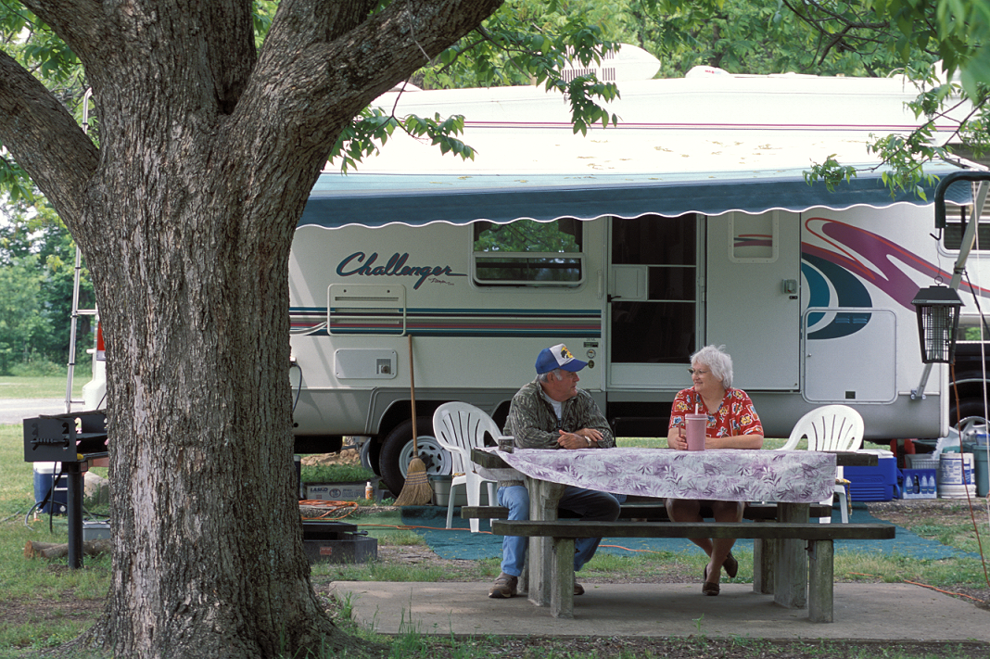
- Travel by camper/RV accounts for 17.9 million person-trips. The majority (89%) are taken for leisure purposes. Camper/RV person-trips are most often generated for the primary purpose of outdoor recreation (43%). The top activities on camper/RV person-trips are engaging in outdoor activities (e.g. hunting, fishing, hiking) (41%) and visiting national or state parks (29%).

- On average, households spend $429 per camper/RV trip, not including transportation to the destination. On one in four (26%) spend $500 or more.

- Virtually all (96%) person-trips taken by camper/RV involve an overnight stay. Camper/RV overnight trips last an average of 6.2 nights, much longer than for primary rental car (4.6 nights) or car/truck (3.5 nights) travel. Three in ten (29%) camper/RV trips involve stays of seven nights or more.

- Camper/RV traveling households primarily lodge in RVs or tents (88%) on overnight trips, yet some spend part of their trip in hotels, motels or bed and breakfast establishments (11%) and/or in homes of friends or relatives (6%).

- More than half (54%) of camper/RV trips are generated by two or more adults from the household.

- A majority (55%) of camper/RV trips are taken by households headed by someone age 55 or older. One third (35%) are generated by households headed by someone that is retired.

- Most (68%) camper/RV trips are taken by households that actually own a motor home/travel trailer/RV.

- More than half (54%) of camper/RV trips include two or more adults from the household, a much larger share then an owned car/truck (36%). One quarter (23%) are taken by an adult traveling alone (or with someone outside the household). One quarter (23%) also include children from the household.
Source: Auto Travel in the U.S. 2003 Edition, Travel Industry Association of America
3/33
Shopping Travelers

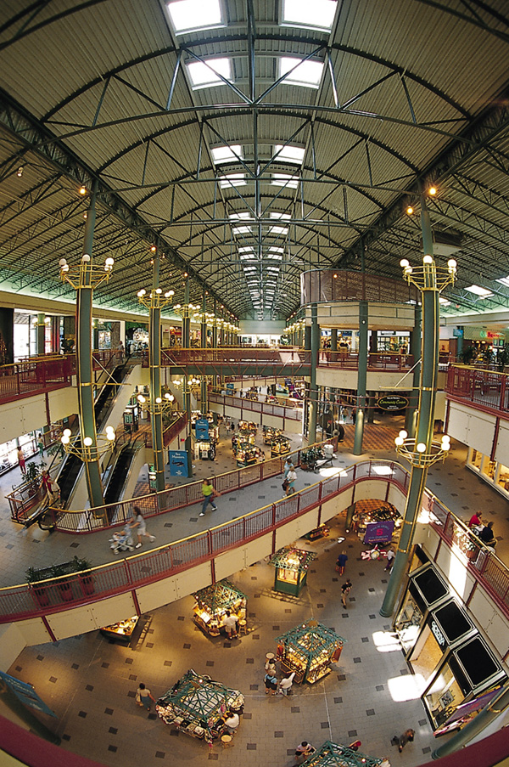
Shopping is an integral element of the travel experience for U. S. residents, according to a first-ever comprehensive research study of the relationship between travel and shopping. The study, The Shopping Traveler, was conducted by the Taubman Centers Inc., a real estate investment trust that develops and manages shopping centers throughout the U. S.

Based on a representative sample survey of 1,000 U. S. adults who took at least one trip in 2000, the January 2001 study indicates that more than half (51%) of all shopping travelers say that shopping was the primary or secondary purpose of one or more of their trips taken within the past year. The study disproves an old stereotype regarding what people buy while on trips. According to the survey, shopping travelers most often spend money on clothes or shoes for themselves or others (77%), rather than on souvenirs. TIA estimates that travelers spent approximately $37.3 billion*, in total, on retail trade purchases while shopping in 1999, the latest data available.

The Shopping Traveler Report Highlights:

- Shopping continues to be the most popular of common activities for U. S. travelers. About 91 million people, or 63 percent of travelers in 2000, included shopping as an activity on a trip. Because people can go shopping on more than one trip away from home, TIA estimates that 34 percent of all person-trips or over 345 million U.S. person-trips include shopping.

- Six in ten (59%) shopping travelers obtain information about shopping areas from friends, family or co-workers. Hotels are another popular source for getting information (25%).

- Most (73%) traveling shoppers want to shop at stores they do not have in their home city or town. Over half (53%) of traveling shoppers also say they go shopping on trips to find items that represent the destination they are visiting.

- Traditional enclosed shopping centers or malls are the most popular places to shop on a trip (62%). Half shop at major downtown shopping districts or outdoor “main street” shopping areas (53%) and/or strip malls or plazas that are not enclosed (48%). Four in ten (38%) shopping travelers shop at outlet centers.

- Shopping travelers are likely to be Baby Boomers and have higher-than-average household incomes.

- Shoppers are almost as likely to stay at a hotel, motel, or bed and breakfast establishment (49% of person-trips) as they are with friends or relatives (48%).
3/34
- Overnight shopping trips average 4.8 nights and they spend, on average $563, excluding the cost of transportation to the destination.

- Most (81%) shopping travelers say that their most recent trip that included shopping was for leisure purposes.

* Preliminary figure. Consists of traveler spending on retail trade purchases including gifts for others, clothing, souvenirs, personal services, medicine, cosmetics, and other items of this nature.

Source: Domestic Travel Market Report, 2002 and 2003 Editions; Travel Industry Association of America

3/35
Soft Adventure Travelers
(hikers, bikers, birders, etc.)

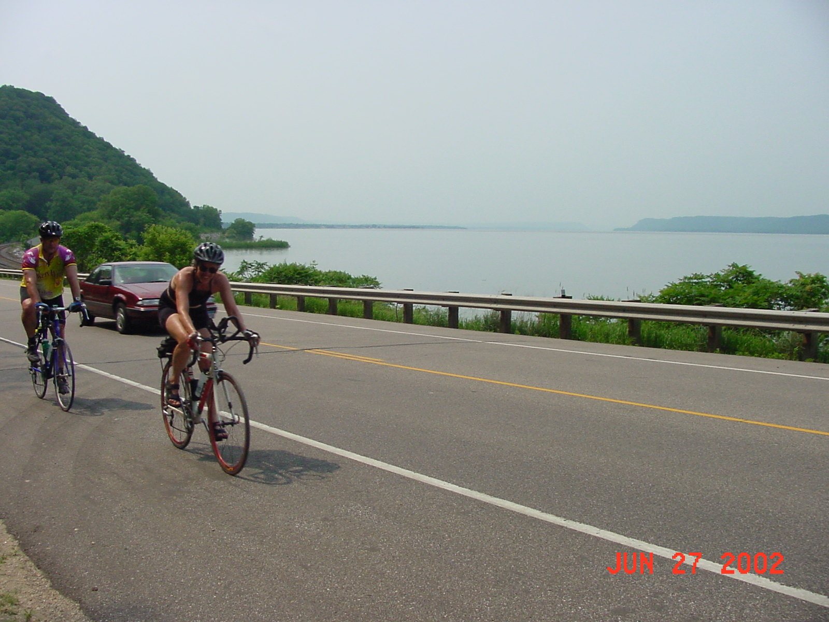
- Adventure travelers participated in an average of three different soft adventure activities in the last five years. The top soft adventure activities in the last five years were camping (64.7 million adults or 33%), hiking on gradually changing terrain (44.8 million adults or 23%) and biking (27.2 million adults or 14%).

- Adventure travelers participated in an average of three different hard adventure activities in the last five years. The most popular ones were whitewater rafting/kayaking (14.8 million adults or 8%), snorkeling/scuba diving (12.4 million adults or 6%) and off-road biking or mountain biking (10.8 million or 5%).

- Spouses (60%) are the #1 companion for soft adventure, while friends (48%) are the #1 companion for hard adventure. A significantly larger share of soft adventure travelers took spouses (60% vs. 42%) and children/grandchildren (41% vs. 18%) on their most recent adventure vacation than did hard adventure travelers. Parents or grandparents were included in one out of ten adventure trips of both kinds.

- One-half of soft adventurers (48% or 44 million U. S. adults) report that interest in the adventure activity prompted their trip. This is a higher than among hard adventurers (39% or 12 million U. S. adults). A larger share of hard adventure travelers say the adventure activity was the secondary reason for the vacation (36% vs. 29%). About one-fourth of each group said the adventure participation was just a trip activity but not a motivator for taking the trip.

- Compared to the total U. S. adult population, hard adventure travelers are more likely to be young, single and with higher household incomes. The typical hard adventure traveler is a 35 year old, with some college education and employed full-time. A higher than average number are men, belong to Generation X, that is 18-34 years old, work in a professional or managerial job and are single. Nevertheless, one-half are married, and one-half have children at home. More than one-half have two or more working adults in the household. One-half earn annual household incomes of $50,000 or more.

- The demographic profile of the soft adventure traveler is similar in many ways to the total U. S. adult population. Specifically, seven in ten have attended some college, and two-thirds are married. All income levels are represented within the soft adventure group. Soft adventurers differ from the total U. S. population in that they are younger, typically ages 18-44, and a higher share are employed full-time, in households with two wage earners and with children at home.

Source: Adventure Travel Report, 1997; Travel Industry Association of America
3/36
Sporting Events Travelers

- U.S. resident travel has increased significantly in volume during the 1990s. In addition, Americans have been taking a much wider variety of trips than in earlier decades. Sports events-related travel has been growing in popularity.

- Two-fifths of U.S. adults are sports events travelers. In the past five years, 75.3 million U.S. adults attended an organized sports events, competition or tournament as either a spectator or as a participant while on a trip of 50 miles or more, one-way, away from home.

- Men outnumber women as sports events travelers. 45 percent of men (42.7 million) and 31 percent of women (32.6 million) attended sports events while traveling in the past five years.

- Baseball leads as the most preferred sports event during travel, followed by football, basketball and auto/truck racing. Men and women report similar preferences in these activities.

- Professional and amateur sports events are attended equally while traveling. Among amateur events, high school and college sports are most popular.

- Attending the sports event is the primary purpose of the trip for most sports events travelers (76%).

- Most sports events travelers are spectators (84%). One-fourth of all sports events travelers attended events to watch their children or grandchildren play.

- Two out of five sports events travelers made a special purchase of sports equipment or clothes for their trip, spending an average of $119 each.

- Attending sports events ranks 10th as a trip activity. Six percent of all 1997 U.S. resident person-trips (60 million) included sports events as a trip activity.

- Summer is generally the most popular season for sports events travel. "Sports events only" travelers (i.e., participating in no other trip activities) and the lowest spending group of sports events travelers (i.e., those spending less than $100 per trip), however, show a slight preference for the fall.
3/37
- Most sports events travelers are on pleasure trips (78%), usually focused on entertainment and outdoor recreation. "Multi-activity" travelers (i.e., those enjoying other trip activities in addition to sporting events) are more likely to be visiting friends and relatives, while those in the highest spending category ($500 or more), are more likely to be traveling on business.

- Most sports events travelers drive to their destinations, as is true for U.S. travelers overall. Air travel is more common among multi-activity travelers, and among those spending $500 or more per trip.

- The average party size of sports events travelers is similar to all U.S. travelers, but a higher percentage of sports events parties have children (30% vs. 21%).

- Most sports events travelers stay overnight in a hotel, motel or bed and breakfast (52%). Although a higher percentage stay in a hotel/motel/ B&B, sports events travelers average fewer nights in the hotel than do U.S. travelers overall. Multi-activity travelers and those in the highest spending category are most likely to stay at a hotel/motel/B&B and report longer trips, on average. Sports event only travelers and those in the lowest spending group are much more likely to travel just for the day.

- Sports events traveler spending is similar to the spending done by all U.S. travelers. Multi-activity travelers spend more than sports event only travelers ($615 vs. $235, mean).

- Similar to all U.S. travel, the largest share of sports event travelers come from and go to the South census region. Sports events travelers, however, are more likely than all U.S. travelers to originate from and travel to the Midwest census region.

- Sports events travelers are generally younger than total U.S. travelers. They are also more likely to have children and be employed full-time. Sports events only travelers are more likely than multi-activity travelers to be married and have children.

- Sports events travelers like all travelers, are most likely from the Parents Life-stage. Coinciding with the higher share of children, sports event travelers, and especially sports event only travelers, are more likely than other travelers to be in the Parents Life-stage.

Source: Profile of Travelers Who Attend Sports Events, 1999 Edition; Travel Industry Association of America

3/38
Travelers with Pets

- Americans love their pets and treat them like family, as evidenced by the increasing number of pet spas, doggie daycare and animal "cafes." In keeping with that trend, owners apparently also want to share their travel experiences with their pets, with quite a few travelers taking them along on trips. Fourteen percent of all U. S. adults say they traveled with a pet on a trip of 50 miles or more, one-way, away from home in the past three years, according to a January 2001 Travel Poll by the Travel Industry Association of America (TIA). This translates to 29.1 million Americans traveling with pets in the past three years. The love for traveling with pets knows no class or educational barriers, as travelers reporting taking pets with them are spread across all socio-economic and educational levels. Travel Poll results are based on a representative sample survey of 1,300 U. S. adults.

- Among adults traveling with pets, dogs are the most common type of pet to take along with about eight in ten (78%) travelers reporting taking a trip with "Fido." Cats came in a distant second with 15 percent of travelers taking their feline friend along. A few report traveling with birds (2%) and either a ferret, rabbit, or fish (3%).

- Not surprisingly, adults traveling with pets are most likely (76%) to say an auto or truck was their primary mode of transportation. Travel via a recreational vehicle came in a distant second with 10 percent using this mode. Six percent indicated they traveled by air with a pet.

- Travelers with pets are most likely to stay with friends or relatives (32%) while traveling. However, it's interesting to note that an almost equal number-three in ten- of travelers (29%) share a hotel or motel room with their pet. Others say they spent most of their nights in a camper, trailer, recreational vehicle, or tent (16%) or in a cabin, condominium, or vacation home (10%). On the most recent trip with a pet, women are twice as likely as men to indicate they lodged at the home of a friend or relative (43% vs. 21%).

Source: Domestic Travel Market Report, 2002 Edition; Travel Industry Association of America

3/39
Weekend Travelers

- Half of all U. S. adults report taking at least one weekend trip* in the past year, according to a January 2001 Travel Poll by the Travel Industry Association of America (TIA). That's almost 103 million adults who find themselves on the road for at least a Friday, Saturday, or Sunday night stay. Almost 30 percent of Americans have taken five or more weekend trips in the past year and 35 percent say they've taken their children with them during weekend travel.

- With 52 weekends a year to choose from, travelers have the flexibility to make spur-of-the-moment decisions about going away. Four in ten (42%) weekend travelers make last-minute plans and select their destination within two weeks of their trip. Nearly 20 percent of weekend travelers selected a destination three to four weeks before traveling. Another 38 percent plan ahead selecting a destination more than one month before the trip.

- Thirty percent of weekend travelers say they took advantage of discounts, coupons, or special offers while planning or while on their most recent weekend trip. Friends, family, or co-workers (20%) are the most popular source for information about such offers, followed by Web sites (17%), and travel guides, books, or magazines (16%). One in ten say they found out about special offers or discounts by reading newspaper travel sections (11%) and/or by making phone calls to or visiting an airline, hotel, car rental, or other travel company (9%).

- Compared to five years before, day trips and weekend trips appear to be more popular than trips lasting about one week or longer. In fact, forty percent of weekend travelers report they are taking more day trips and/or weekend trips (38%) now than five years ago. Interest in longer trips lasting more than one week seems to be declining - 43 percent of weekend travelers claim they are taking fewer long trips than they did five years ago.

- Traveling by car (74%) is the most popular mode of transportation for weekend trips, followed by air (16%). Weekend travelers most often (47%) stay at a hotel or motel, while 33 percent stay with friends or relatives.

*NOTE: A weekend trip is defined as an overnight leisure trip of one to five nights away from home traveling at least 50 miles or more, one way and including a Friday, Saturday, or Sunday night stay. The Weekend Travel Poll is based on a representative sample of 1,300 US adults.

Source: Domestic Travel Market Report, 2002 Edition; Travel Industry Association of America
3/40

DO NOT COPY THIS PAGE. IT IS HERE SINCE A DIVIDER WILL BE PUT IN ITS PLACE.

Funding Resources

Grants: General Resources

- TGCI: The Grantsmanship Center – grant information and grantsmanship training; conducts workshops in grantsmanship and proposal writing around the country.
URL: http://www.tgci.com/

- GrantsWeb: SRA International Grants Web – grant information on general resources, private funding, government resources and policy information & regulations.
URL: http://www.srainternational.org/newweb/grantsweb/index.cfm

Foundation & Nonprofit Grants

- The Chronicle of Philanthropy: The Newspaper of the Nonprofit World – newspaper published every other week; news source for charity leaders, fund raisers, grant makers & other people involved in philanthropic enterprises; publishes The Chronicle Guide to Grants, a subscription database of all corporate & foundation grants listed in The Chronicle since 1995.
URL: http://philanthropy.com/

- Community Foundation Locator – searchable database of community foundations, sponsored by the Council on Foundations.
URL: http://www.communityfoundationlocator.com/search/index.cfm

- Council on Foundations – a nonprofit membership association of grantmaking foundations & corporations; source of information for foundations on day-to-day grantmaking activities.

URL: http://www.cof.org/

- The Foundation Center: Your Gateway to Philanthrophy on the World Wide Web – publishes databases (such as the Foundation Finder), directories & guides (such as the Foundation Directory) to aid in researching private foundations and learning about grantseeking & grant proposal writing.
URL: http://www.fdncenter.org/
3/41
GrantSmart – this site features a searchable database of tax-related information for each of 60,000 private foundations that file Form 990-F with the IRS.
URL: http://www.grantsmart.org

- GuideStar: The National Database of Nonprofit Organizations – a searchable database of more than 700,000 U.S. nonprofit organizations; provides financial data on foundations & nonprofits from the IRS Form 990-F.
URL: http://www.guidestar.org/

- Internet Nonprofit Center: Information For & About Nonprofit Organizations –offers information for and about nonprofit organizations in the U.S., featuring a Nonprofit Online News and a Nonprofit Library
URL: http://www.nonprofits.org/

Federal Government Grants: General

- Catalog of Federal Domestic Assistance (CFDA) – a searchable database of information on Federal grant programs that provide assistance (15 types of assistance & 1,453 assistance programs administered by 63 Federal agencies), containing financial & nonfinancial assistance programs of the Federal government; has a web page on developing & writing grant proposals.

URL: http://www.cfda.gov/

- E-Grants Program Management Office – the electronic storefront for federal grants. One of 24 initiatives of the E-Government program for improving access to government services through the internet.
URL: http://www.grants.gov

- Federal Demonstration Partnership (FDP) – a cooperative initiative among Federal agencies and institutional recipients of Federal funds, established to streamline the administrative process & minimize the administrative burden on principal investigators.
URL: http://www.thefdp.org

- Federal Register via GPO Access – announcements of new Federal grants are published in the Federal Register daily (Monday – Friday); the Government Printing Office maintains a searchable database, GPO Access, for searching the Federal Register.

URL: http://www.gpoaccess.gov/fr/index.html
3/42
- NonProfit Gateway: Network of Links to Federal Government Information & Services – this is a Federal government web site that provides links to Federal agencies that offer grant programs or programs for nonprofits.
URL: http://www.nonprofit.gov/

Federal Government Grants: Selected Agencies

- Department of Agriculture – Rural Business-Cooperative Service
URL: http://www.rurdev.usda.gov/rbs/busp/bprogs.htm

- Department of Commerce
URL: http://www.osec.doc.gov/oebam/grants.htm

- Department of Education: Grants & Contracts Information
URL: http://www.ed.gov/index.jsp

- Department of Health & Human Services: GrantsNet

URL: http://www.hhs.gov/grantsnet/

- Department of Transportation
URL: http://www.dot.gov/ost/m60/grant/

- Institute of Museum and Library Services (IMLS)
URL: http://www.imls.gov/grants/index.htm

- National Endowment for the Arts (NEA)
URL: http://arts.endow.gov/guide/

- National Endowment for the Humanities (NEH): Grants & Applications

URL: http://www.neh.fed.us

National Institutes of Health (NIH): Funding Opportunities
URL: http://grants.nih.gov/grants/index.cfm

- National Park Service
URL: http://www.cr.nps.gov/helpyou.htm
3/43
- National Scenic Byways Program
URL: http://www.byways.org

- National Science Foundation (NSF): Grants & Awards
URL: http://nsf.gov/home/grants.htm

- National Telecommunications & Information Administration (NTIA):
Technology Opportunities Program (TOP)
URL: http://www.ntia.doc.gov/otiahome/top/grants/grants.htm

- National Trust for Historic Preservation
URL: http://www.nthp.org

- Save America’s Treasures – a public/private partnership between the National Park Service and the National Trust for Historic Preservation
URL: http://saveamericastreasures.org

- Small Business Administration (SBA): Financing Your Business
URL: http://www.sba.gov/financing/

Source: Delta Grants Resource Center, Dean B. Ellis Library, Arkansas State University
3/44

