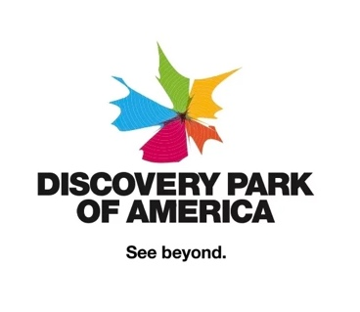

August 23, 2023

Mississippi River Parkway Commission, Culture & Heritage Committee
National MRPC Office
PO Box 7395
Madison, WI 53707-7395

Dear Mississippi River Parkway Commission, Culture & Heritage Committee:

Discovery Park of America would like to apply for inclusion among the Great River Road network of museums and interpretive centers. As you’ll see from our application, our $100-million-dollar museum and heritage park includes highlights of the people, culture and wildlife of the Mississippi River along with Reelfoot Lake and the Obion River.

The mission of Discovery Park is to create and serve the public as a premier museum and educational institution, with an emphasis on assembling, displaying, preserving and/or protecting important and interesting artistic, cultural, historical and scientific items, collections, works and exhibits dedicated to and celebrating the human experience; specifically, our culture, our spirit, our accomplishments and our history, with an emphasis on Northwest Tennessee's unique cultural heritage and natural history. That includes our region's unique relationship with the Mississippi River.

Our museum's focus also includes efforts to foster an interest in the appreciation and exploration of and knowledge regarding natural and cultural history, science, technology and the arts by using its collections and resources to enlighten, educate, engage and delight children and adults through well-designed exhibits, creative and engaging public programming, ongoing thought leadership and academic excellence.

We believe our museum and heritage park, along with our educational initiatives, warrant inclusion as a museum on the Great River Road.

Sincerely.

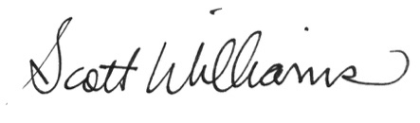
Scott Williams
President and CEO
Discovery Park of America
830 Everett Blvd., Union City, TN 38261
Phone: 731-599-9749
DiscoveryParkofAmerica.com
swilliams@discoveryparkofamerica.c

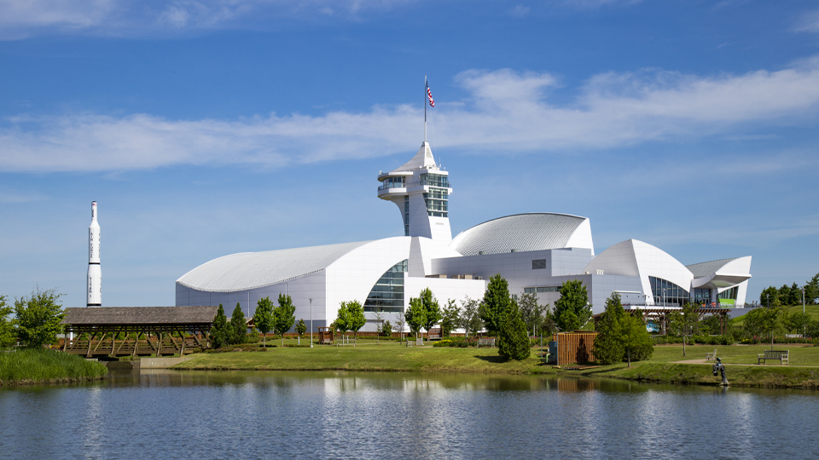

APPLICATION

1. What story does your institution tell about the Mississippi River as part of its regular daily visitor experience? How does it relate to the themes for interpretation which are attached? Why do you feel that this significant aspect or relationship to the river is presented at a high level of quality? Describe the quality of the visit your guests receive.

There are numerous ways that Discovery Park of America offers Mississippi River-related experiences through our exhibits, programming and the character of our location. Many of these tie into one or more of the 11 designated themes including the river’s role as a source of life for people, plants, and animals; the influence of people on the river and the importance of conservation; prehistoric cultures around the river; folklife including literary, fine art and music; American history; and transportation.

LOCATION
While we are located in a second-tier county from the Mississippi River, Tennessee’s Great River Road Corridor Management Plan identifies Union City, the location of Discovery Park, as a gateway to the Great River Road. It’s also noteworthy that we are separated from the river itself by Lake County, the narrowest county on the river. We are located just 13 miles from Hickman, Ky which is on the river. When ships from the American Queen Steamboat Company dock in Columbus, Ky., 27 miles from the museum, Discovery Park is utilized as the excursion for their guests. Location on Google Maps.

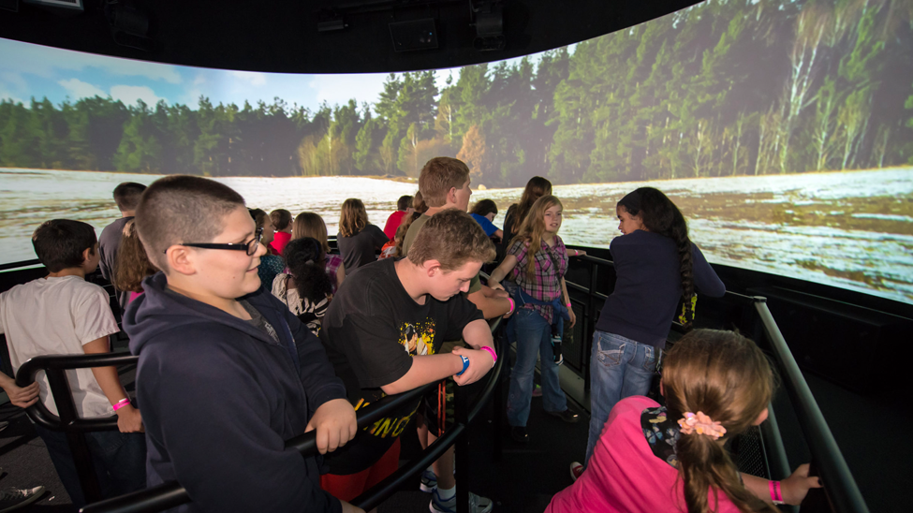

REELFOOT LAKE
Discovery Park celebrates the unique cultural heritage and natural history of Northwest Tennessee, the Mississippi River, Reelfoot Lake, the Obion River and the other natural attractions around us. Our 10-minute immersive Earthquake Simulator features a surround screen and moving platform that takes guests back in time to experience firsthand the science behind the 1811 and 1812 earthquakes along the New Madrid Fault Line. The earthquakes contributed to the creation of Reelfoot Lake as the Mississippi River flowed backward and filled in the gaping hole that was formed.

The supercontinent Rodinia formed between 950 million and 1.3 billion years ago. Around 750 million years ago, it began breaking apart. Rifts or faults formed between the continental plates. Some 600 million years ago, our continent tried split along what we now call the Reelfoot Rift at New Madrid. But the split did not occur. Geologically, it stalled. Still, the attempted breakaway weakened the continental plate.

The failed rift during the Rodinia supercontinent break up defines, in part, the earthquakes in this area. The other part is the Mississippi River Embayment. The continental fragments that separated during the Rodinia breakup rejoined about 300 million years ago to form the new supercontinent of Pangea.

Then, about 205 million years ago, Pangaea began detaching into the continents we know today. During North America’s migration, the continuous mountain range blocking the Mississippi River’s outlet southward to the emerging Gulf of Mexico separated into the Ouachita and Appalachian mountains, opening a gap or embayment. Water filled the embayment, and for millions of years, the river’s sediment pushed the land outward into the Gulf.

The New Madrid Seismic Zone is located at the northern end of the embayment. The United States Geological Survey explains that “the relatively unconsolidated material in the Mississippi embayment amplifies the ground shaking and also traps seismic energy to prolong the duration of ground shaking.” So, the failed rift and soil characteristics of the Mississippi Embayment define the New Madrid quakes.

From the interactive 20-minute experience at Discovery Park, guests learn about the natural state of the area before the earthquakes, what those in the area experienced and how the impact of the quakes can still be seen in the area today. Quotes from those who were living and working on the Mississippi River at the time are included in the experience.

On the center Reelfoot Rift, which lies just southeast of Union City, the quake exhibited what geologists call a reverse fault motion, where one side moves up above the other. During the earthquake that took place on February 7, 1812, the land south of the fault rose by as much as 33 feet.

Reelfoot Lake formed when the uplifted land, or scarp, blocked Reelfoot Creek, which flowed to the Mississippi River. So, the creation of Reelfoot Lake is about both the uplift damming the flow and the land dropping underneath it.

WILDLIFE
The fish in our 20,000-gallon aquarium would be right at home in the Mississippi River. Included are largemouth bass, black crappie, bowfin, shortnose gar, longnose gar, smallmouth buffalo and blue and channel catfish. Housed in several smaller tanks in the gallery are a red-eared slider turtle, snapping turtle and eastern box turtle. There are also several snakes, including a speckled king snake, corn snake and pine snake.

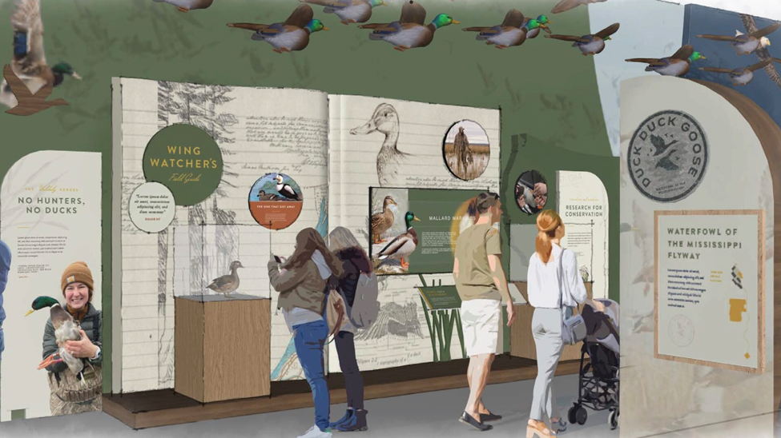

WATERFOWL OF THE MISSISSIPPI FLYWAY
Opening Nov. 10, 2023 at Discovery Park in partnership with Ducks Unlimited, The Tennessee Wildlife Resources Foundation and others is "Duck, Duck, Goose: Waterfowl of the Mississippi Flyway." In this new, one-million-dollar permanent exhibit, guests will discover how a combination of federal land protections and private land conservation unites the government, landowners, hunters, scientists, conservationists and other nature lovers to protect and restore waterfowl populations and the land needed for them to thrive. Included is:
- The Wing Watcher’s Field Guide – a multimedia, interactive table that helps guests identify ducks, geese and other waterfowl found along the Mississippi Flyway.
- A closer look at illustrator Anhus Shortt, one of the world’s most recognized artists of waterfowl and their habitats, along with the role the arts play in conservation along the flyway.
- Interactive experience focused on the Federal Duck Stamp Program and the student category that highlights the role of art in conservation.
- An overview of the work of the Cohen Wildlife Ecology Lab that is using cutting-edge research and GPS technology to track waterfowl migrations down the flyway. Guests learn why ducks migrate along the Mississippi River, where they go and how they get there. An interactive touch station activates media playback and a closer look at data gathered each year and its impact on conservation.
- The Ducks Unlimited Conservation Experience includes three horizontal monitors that create a cinematic canvas that expands 13 feet across an immersive wetland environment. Interviews with hunters, researchers and lovers of nature and the outdoors share a passionate narrative about preserving the future of waterfowl hunting and conservation all along the Mississippi Flyway.
- The differences in hunting styles in the various areas along the Mississippi Flyway including the Great Lakes, the Plains and the Wetlands.
- The story of Akers v. Resor, a lawsuit in which Clark Akers III and three other duck hunters brought a suit against the U.S. Army Corps of Engineers. The Corps was intent on channeling some of the Mississippi River’s tributaries to prevent flooding and create more farmland. Previous initiatives that were similar had destroyed the land around the tributaries and rendered them useless for wildlife. After 15 years, the men won. Today, their victory is considered the greatest in the history of the American grassroots conservation movement.

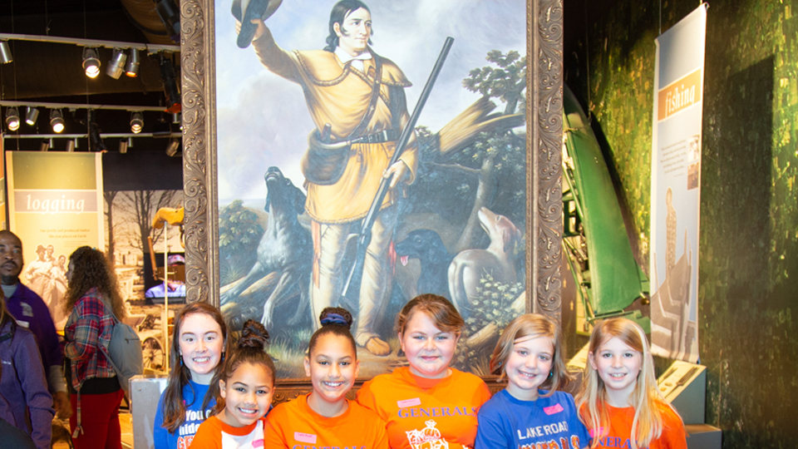

DAVID CROCKETT AND EARLY SETTLERS
There are many places at Discovery Park of America where guests can experience folk hero, frontiersman, politician and West Tennessee settler David Crockett. He lived in our region from 1822 until he departed for the Alamo in 1835. Crockett was also one of the earliest hunters around nearby Reelfoot Lake and his use of the area's rivers—including the Mississippi—is included in the exhibit and film.

One of Crockett’s most life-changing moments actually took place because of the Mississippi River. 1825, he hired a team of men to chop down trees along the Obion River and cut them up into pieces that would be sold to create barrels. After they stacked the wood on longboats, they steered them down the Obion River to where it meets the Mississippi River. From there they attempted to float downstream to New Orleans and sell the staves. Unfortunately, right outside of Memphis, they hit a turn in the river known as the Devil’s Elbow and lost both their boats and the wood. After being rescued, Crockett met the first mayor of Memphis, Marcus Winchester. Not only did they remain close friends for the rest of Crockett’s life, but Winchester also became a secret funder of Crockett’s future political campaigns.

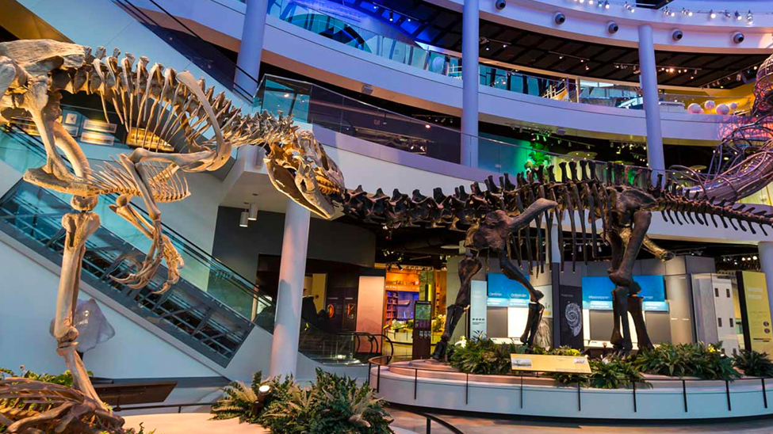

PREHISTORIC CULTURES AROUND THE RIVER
In the 4.5 billion years since our planet first formed, continents have been born, forced together and ripped apart. Discovery Park’s Natural History Gallery was created by geologists, paleontologists and other earth scientists to present that story and how it impacted the natural history of our region which borders the Mississippi embayment. Numerous exhibits in this gallery trace our region’s history from the appearance of complex life in the Late Paleozoic Era, to the dominance of the dinosaurs during the Nesozoic and finally the beginning of the human species in the Cenozoic. Large fossil reproductions of dinosaurs and marine reptiles from the Mesozoic Era dominate Dino Hall and make for a dramatic beginning for a tour of the museum.

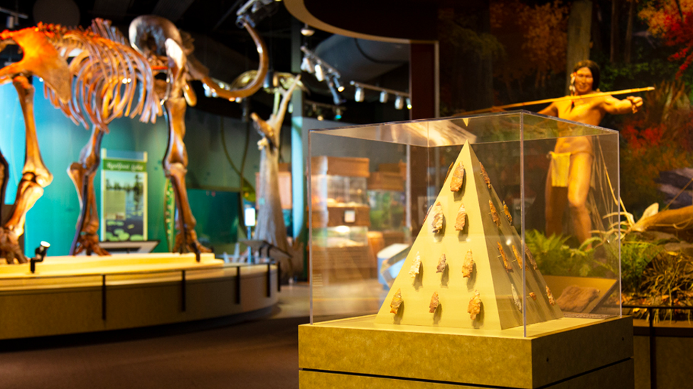

Native American Gallery
Numerous groups of people have settled in Tennessee beginning with Native Americans about 15,000 years ago. Prominent early tribes in Tennessee were the Cherokee and the Chickasaw. The Chickasaws claimed most of Western Tennessee as their hunting grounds. Discovery Park’s Native American Gallery explores the five major time periods of Native America culture, taking guests from the ancient past, through European contact and up to today with emphasis on the cultures of the Cherokee and Chickasaw. Many of the artifacts were part of the private collection of Aaron Clement who spent his life roaming the fields, creek beds and rivers of our region looking for the artifacts that can now be seen at Discovery Park.

QUALITY OF EXPERIENCE
Discovery Park is known for the quality of the experience guests receive. That includes the cleanliness of the museum and grounds, the technology and hands-on experiences, the highest level of customer service and the dedication of adherence to museum best practices.

2. What is the length of stay for the typical visitor experience at your institution? Please provide what you consider an average time, what you consider a short stay and what you consider a long stay for regular attendance.

With three new hotels next door and another one opening up down the street, we're seeing an increase in two-day visits. Some of the highlights can be experienced in four hours or so, but at least a full day is required to experience the entire museum and park.

3. What educational or interpretive programs beyond exhibits do you conduct that interpret the Mississippi River or some significant aspect or relationship to the river?

BIRDS OF PREY
We frequently host Tennessee State Park rangers who provide interpretive programs with birds of prey and other animals who make the Mississippi River region in Tennessee and Kentucky their home.

TENNESSEE NATURALIST PROGRAM
The Tennessee Naturalist Program Each year since 2019, Discovery Park has been a partner and location for The Tennessee Naturalist Program. The mission of the program is to teach Tennesseans about nature in the state, instill an appreciation of responsible environmental stewardship and channel volunteer efforts toward education of the general public and conservation of Tennessee’s natural resources both on land and water. Individuals who complete Discovery Park’s course gain an understanding of native ecosystems throughout the state, but especially here in Northwest Tennessee along the Mississippi River.

Courses with topics with content specific to the Mississippi River are “Tennessee’s Living Waters,” “The World of Invertebrates” and “Tennessee Birds.” These take place at several lakes and rivers in the area.

After the course, Tennessee Naturalists participate in many different types of volunteer activities, such as helping a nature outreach program at a park, museum, nature center or school, assisting in collection of scientific data for bird census, water quality assessment or rare plant monitoring and working with trail maintenance or habitat restoration projects.

COON CREEK SCIENCE CENTER
Discovery Park partners with the Coon Creek Science Center, one of the most important fossil sites in the country, with exhibits and programs. The 240-acre field site, located in McNairy County, Tenn. just 20 miles from the Mississippi River, is a 70-plus million-year-old exposed seafloor deposit that’s home to almost 700 preserved marine species. In addition to an exhibit of fossils on display at Discovery Park, educators from the science center frequently join Discovery Park’s educators for hands-on programs to teach the ecology of the area. Currently in development in partnership with Coon Creek is a man-made dig site for children at Discovery Park.

OTHER PROGRAMS
We incorporate the themes and content of our many exhibits into programs and events at the museum each week. This includes Homeschool Days, Saturday programs, members-only programs and events and our bi-monthly podcast, “Reelfoot Forward: A West Tennessee Podcast.”

Our president, Scott Williams, is currently on the Tennessee Tourism Committee of the Department of Tourist Development for the State of Tennessee, the boards of the Obion County Chamber of Commerce, the Northwest Tennessee Tourism Committee and Hospitality Tennessee, the advisory board of the UTM College of Business and Global Affairs and the Northwest Tennessee Arts Center Advisory Board. He is able to represent the organizations we partner with in that capacity. Additionally, we have an information desk staffed with volunteers who help our visitors learn more about the area utilizing brochures and maps that are available there.

4. What are your published and regular hours? Please describe hours for various seasons.
March – August 2023
Open 10 a.m. – 5 p.m. on Monday – Saturday
Open 11 a.m. – 5 p.m. on Sunday
Closed on Easter, Apr. 9, 2023.

September – December 2023
Open 10 a.m. – 4 p.m. on Tuesday- Saturday
Open 11 a.m. – 4 p.m. on Sunday
Closed Mondays, Thanksgiving Day, Christmas Eve and Christmas Day.
Open on Labor Day, Monday, Sept. 4, 2023

5. What is the annual attendance for regular museum hours at your site, exclusive of special events? What is the admission fee?
An average of 250,000 per year.

GENERAL ADMISSION
- Adult (18 and older): $21.99
- Child (4-17): $14.99
- 3 and under are free

VIP DISCOVERY PACKAGE
BEST VALUE! This is a great package to enjoy as is or add select attractions to enhance your visit.
Enjoy general admission PLUS:
- Unlimited access to the Cooper Tower
- 10% off in the Gift Shop
- 10% off in the Cafe and Eats & Treats
- Collectible VIP badge
- Adult (18 and older): $29.99*
- Child (4-17): $22.99
- 3 and under are free

EXPLORER PLUS PACKAGE
BEST VALUE FOR ALL INCLUSIVE!
Explore the whole museum and park with a ticket to Discovery Park and a ticket to all the special attractions where you and your family can relax and recharge throughout the day. With your Explorer Plus Package, you will also get:
- Unlimited access to the Cooper Tower during park hours
- One ticket to the Discovery Theater “Dinosaurs of Antarctica 3D”
- One ticket to the Discovery Theater “Tiny Giants 3D.”
- One ticket to the Earthquake Simulator
- 10% off in the Gift Shop and the Hugh Wade Feed Store
- 10% in Sabin’s Cafe and Eats and Treats
- Discovery Park of America Guidebook
- Explorer Plus Package Pricing:
- Adult (18 and older): $64.99
- Child (4-17): $39.99
- Children 3 and under are free.

SPECIAL ATTRACTION PRICING:

DISCOVERY THEATER
Two award-winning 3D films, “Dinosaurs of Antarctica 3D” and “Tiny Giants 3D.” $5.99.

EARTHQUAKE SIMULATOR
10-minute story and simulation of historic earthquakes. Show begins every 30 minutes. $5.99

THE TOWER
Ride the elevator up 120 feet and see for miles! $5.99

6. What is your proximity to the Great River Road?

We are located 15 miles from Hickman, Ky, 28 miles from Columbus Belmont State Park, 24 miles from the Reelfoot Lake State Park Welcome Center and 38 miles from New Madrid, Mo.

